**How God has helped me crack the Amazon Interview in 2024**

**My path to an Amazon Offer — To Christ be all the Glory!**

[[](https://medium.com/@rogernem?source=post_page-----3419e4a7b21b--------------------------------) Roger Nem](https://medium.com/@rogernem?source=post_page-----3419e4a7b21b--------------------------------) 8 min read May 7, 2024



My path to an Amazon Offer — To Christ be all the Glory! (picture by author)

This is a series of articles where I dive deep into the various steps I have undertaken to secure a role as a **Sr. Technical Account Manager** (L6) at one of the largest technology companies in the world: [**Amazon Web Services (AWS)**](https://aws.amazon.com), given the intricate and challenging nature of the Amazon Interview process.

And I could not start this series without praising my Lord and Savior Jesus Christ first, because without Him I would not have made it, specially having to endure all the personal and professional challenges I faced throughout this entire process (all described below).

# Article Series

1. Overview of the Amazon Interview Process
2. Amazon Leadership Principles
3. Resume and LinkedIn Profile
4. My Job Application at AWS
5. Preparation, Study, and Tips **(Published below)**[**Situation (S)**](https://medium.com/@rogernem/how-god-has-helped-me-crack-the-amazon-interview-in-2024-3419e4a7b21b#677c)[**Task (T)**](https://medium.com/@rogernem/how-god-has-helped-me-crack-the-amazon-interview-in-2024-3419e4a7b21b#611c)[**Action (A)**](https://medium.com/@rogernem/how-god-has-helped-me-crack-the-amazon-interview-in-2024-3419e4a7b21b#fb85)[**Result (R)**](https://medium.com/@rogernem/how-god-has-helped-me-crack-the-amazon-interview-in-2024-3419e4a7b21b#17cc)
6. Interviewing at Amazon
7. Receiving my Amazon Job Offer

**NOTE**: Make sure to check back regularly because I will be publishing each part of the series once a week and updating the links above.

# Quick Overview

**Role** : Sr. Technical Account Manager (L6)  
**Applied Through**: Amazon Jobs — Recruiter reached out  
**Total interviews**: 8 (1 Recruiter screening + 1 phone-screening + 6 loop interviews)  
**Duration**: 3 months  
**Result**: Offered  
**Overall Experience**: 4/5

# Situation (S)

I recall it being close to Thanksgiving when a series of unfortunate events began unfolding, one after another:

* I experienced an allergic reaction to a medication a prescribed medication that rendered me unable to speak, which landed me in the hospital for 10 days straight, leaving my wife and baby son to manage on their own.
* During this time, my senior father was diagnosed with a heart condition that required a risky heart bypass surgery (Angioplasty).
* Doctors discovered a potential blood clot forming in a vein in my senior mom’s brain during a routine checkup and advised immediate surgery.
* My father-in-law had been diagnosed with several different types of cancers a few months back.
* A significant reorganization occurred at my former company.

This situation reminded me of the story of Job in the Bible. When I found myself unable to comprehend anything, God spoke:

“For my thoughts are not your thoughts, neither are your ways my ways,” declares the LORD. “As the heavens are higher than the earth, so are my ways higher than your ways and my thoughts than your thoughts” — **Isaiah 55:8–9**

Despite feeling overwhelmed, I found comfort in remembering the words of God:

“So do not fear, for I am with you; do not be dismayed, for I am your God. I will strengthen you and help you; I will uphold you with my righteous right hand” — **Isaiah 41:10**

# Task (T)

Knowing that I was the sole breadwinner of my family, I realized I couldn’t afford to allow that moment to take over and give up. I had to keep fighting, but now with even greater determination than ever before.

I always had a vision of working for AWS, and this became the perfect moment to pursue that dream. I must admit, it was incredibly difficult to stop dwelling on all the recent bad news, but I knew I had to keep pushing forward and prepare myself.

If you’re wondering how to get a job at Amazon, the key is **PREPARATION** and **DEDICATION** and I cannot stress this enough. But I must be frank and say that if you’re not willing to invest the effort, it’s best not to invest your time as you might end up feeling frustrated in the end.

# Action (A)

Starting in January, I submitted my job application to Amazon and started to devote significant time and effort to studying. This dedication led to the successful attainment of **all AWS Digital Technology Badges** by February — [LinkedIn Post](https://www.linkedin.com/feed/update/urn:li:activity:7160688918856671232/) | [Credly](https://www.credly.com/users/roger-nem/badges)

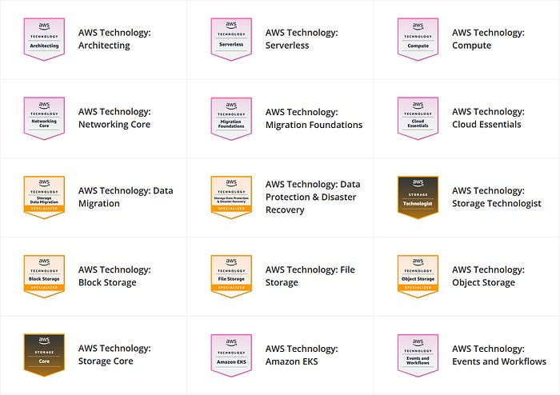

My successful attainment of **all AWS Digital Technology Badges**

I then committed to studying for 12 hours every single weekday and weekend, influenced by numerous articles and the experiences shared by other candidates, because I understood that this was no easy task.

Additionally, I divided my days, dedicating part of my time to studying various technology topics, another part to practicing, and the final part to crafting my stories.

* AWS
* Networking
* Compute — Windows
* Compute — Linux
* Compute — Serverless
* Storage & Content Delivery
* Database (RDBMS / NoSQL / DW)
* Administration & Security
* Monitoring
* Analytics (Hadoop/Streaming Data/Machine Learning)
* Deployment & Management (Content/Code Management)
* System Design (Amazon, YouTube, WhatsApp, Twitter, Netflix, Uber, Google, Maps, etc.)

Senior Technical Account Managers must rank 300/400 on all the topics above to even be considered.

**• 300** — You have **in-depth understanding** of features in a real-world environment and applications. You can provide a detailed technical overview of a subset of product/technology features, covering architecture, performance, migration, deployment, and development.

**• 400** — **Subject matter Expert** in service or discipline. You are able to demonstrate a deep level of technical knowledge and experience and a detailed, thorough understanding of the topic. You can provides expert-to-expert interaction and coverage of specialized topics.

And if you’re wondering, thankfully by now my dad had successfully undergone his surgery and was recovering, while my mom was preparing for hers.

A few weeks later, she successfully underwent her brain surgery. However, during her recovery, her stent, which was used to prevent blood clots, shifted, resulting in her suffering a stroke. It was late at night and my dad was not home when it happened.

After suffering a stroke and falling with her face on the floor, being left unattended for 2 hours, my mom had to be rushed to the hospital and undergo five surgeries, one after the other.

When I heard the news, I was devastated and began to feel anxious, but God quickly reminded me of the following verse:

“Do not be anxious about anything, but in every situation, by prayer and petition, with thanksgiving, present your requests to God. And the peace of God, which transcends all understanding, will guard your hearts and your minds in Christ Jesus.” — **Philippians 4:6–7**

I couldn’t afford to stop now; I needed to continue pressing forward. On March 7, I received an email from the HR representative expressing their excitement to move forward with me, which got me really excited. My interview with the Hiring Manager was scheduled for March 25.

# Result (R)

On March 26, I received an email from HR confirming that I had passed the Hiring Manager interview and that the team was moving me forward to the final Loop Interview, scheduled for April 25.

The stakes were incredibly high, and uncertainty threatened to surface. Uncertainty swiftly breeds fear, and fear gradually undermines our faith. Fear can be potent. In fact, it’s one of Satan’s most frequently employed tactics to instill doubt in us regarding God.

Despite our feelings, it’s important to remind ourselves that God is in control. Even when everything around us feels chaotic, we can turn to Scripture to affirm that God has been, is, and will be sovereign over our lives and the world.

Putting so much time into studying meant sacrificing precious moments with my family and cancelling several plans we had already scheduled. However, all the effort paid off in the end.

After navigating a rigorous Amazon Loop Interview, which involved 5 straight hours of interviewing with key figures including the Enterprise Support Manager, Director of Information Technology and Security, Technical Account Manager Leader, Senior Technical Account Manager, Technical Account Manager, and a Bar Raiser I felt confident.

And on April 29, which also happens to be my birthday, I received the incredible news that I had successfully passed. And later I got my job offer and accepted it! I could not be happier.

And we know that God causes everything to work together for the good of those who love God and are called according to his purpose for them. — **Romans 8:28**

Our help is from the Lord, who made heaven and earth. — **Psalms 124:8**

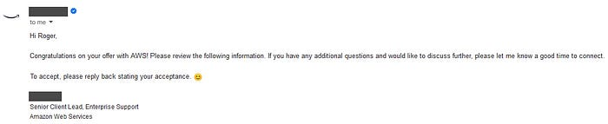

My AWS Job Offer — 🙏🙌😀🥳🎈🏆💪🚀💼👔🎯

By now, my father-in-law is almost cancer free from the different types of cancers he had been diagnosed with.

And about my mom, it’s truly a miracle from God that she survived all her surgeries and has been recovering since then.

I now understand that what occurred with her that day was a divine intervention. If my dad had been at home, my mom would have gone to bed with him, unaware of the moved stent, leading to dire consequences, because no one would have been aware that her stent had moved until the following morning, which could have been too late.

She still cannot speak or move her right side, but blood is beginning to flow back to the side of her brain that was affected. The other day, she babbled “I love you” to my dad. That moment made us incredibly happy and filled us with confidence in a promising future. 😀🙏

I want to conclude by thanking God for this tremendous blessing and expressing my gratitude to my wife for the incredible support she has provided throughout this entire journey. ♥️

# Facts

* **I competed against over 1000 applicants vying for the same position I applied for.**
* **Every new hire at Amazon should be better than 50% of those currently in similar roles — that’s raising the bar.** — [link](https://www.aboutamazon.com/news/workplace/how-amazon-hires)
* **More Than 1 Million People Apply for Jobs at Amazon** — [link](https://press.aboutamazon.com/2021/9/amazon-career-day-2021-more-than-1-million-people-apply-for-jobs-at-amazon)
* **Fewer than 2% of applicants get hired at Amazon.**
* Amazon Web Services (AWS) is a leader in the cloud space and has grown 34% annually over the past two years.
* Amazon was named by LinkedIn as the **№1 company where Americans want to work and develop their careers**, and currently ranks №2 on the World’s Best Employers list from Forbes and on Fortune’s World’s Most Admired Companies list.
* Amazon was also selected by Fast Company as one of the Best Workplaces for Innovators.

**If you enjoyed this article and found it helpful, please don’t forget to leave a heart** ❤**, comment** 💬**, clap** 👏🏻**, and share** ➦ **it to show your support.**

**Also, don’t forget to** [**connect**](https://www.linkedin.com/in/rogertn/)**,** [**follow me**](https://medium.com/@rogernem) **for more articles and support me by** [buying me a coffee](https://buymeacoffee.com/rogernem)**.** :-) **Thank you!**

References:  
- <https://aws.amazon.com/careers/how-we-hire/>  
- <https://aws.amazon.com/premiumsupport/plans/enterprise/>  
- <https://www.linkedin.com/feed/update/urn:li:activity:7160688918856671232/>  
- <https://www.credly.com/users/roger-nem/badges>  
- <https://www.aws.training/>  
- <https://www.amazon.jobs/content/en/how-we-hire/interviewing-at-amazon>  
- <https://www.aboutamazon.com/news/workplace/how-amazon-hires>

[Amazon](https://medium.com/tag/amazon?source=post_page-----3419e4a7b21b---------------amazon-----------------)

[Amazon Web Services](https://medium.com/tag/amazon-web-services?source=post_page-----3419e4a7b21b---------------amazon_web_services-----------------)

[Interview](https://medium.com/tag/interview?source=post_page-----3419e4a7b21b---------------interview-----------------)

[Careers](https://medium.com/tag/careers?source=post_page-----3419e4a7b21b---------------careers-----------------)

[Cloud Computing](https://medium.com/tag/cloud-computing?source=post_page-----3419e4a7b21b---------------cloud_computing-----------------)